Earth and Beyond

Q1) Define Astronomical Unit.

Q2.) Ahmed makes a prediction about the planets in the Solar system.

planet | relative mass compared to Earth | distance from the Sun in millions of km | average surface temperature in Celsius | strength of gravity in N/kg | time to orbit the Sun in Earth years
Mercury | 0.05 | 58 | 169 | 3.7 | 0.2
Venus | 0.81 | 108 | 460 | 8.9 | 0.6
Earth | 1.00 | 150 | 14 | 9.8 | 1.0
Mars | 0.11 | 228 | -63 | 3.7 | 1.9

- Why does Venus have a higher average surface temperature than Mercury? Explain

b) Predict the distance of Jupiter if it’s 3.4 times away from the then Mars

Q3.) Look at the image and name the type of galaxy.
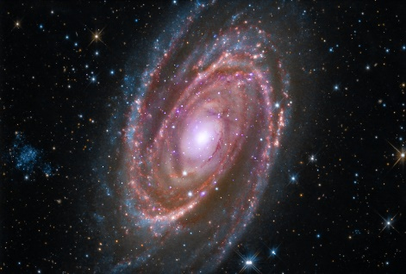
Image credit:- https://www.nasa.gov/mission_pages/chandra/multimedia/spiral-galaxy-m81.html
- Spiral
- Bar spiral
- Elliptical
- Irregular

Answer:-

Q4.) Define an Asteroid.

Q5.) Look the image below and circle the correct option.
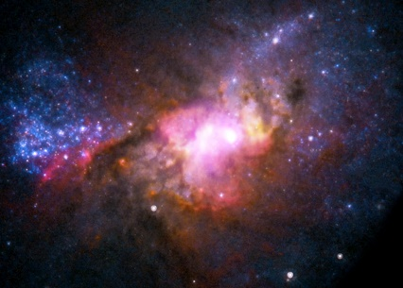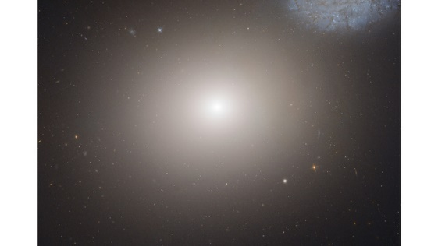

- Elliptical
- Spiral
- Irregular
- None of the above

- 1&2
- 3&2
- 1&3
- 4

Q6) Define a Light year.

Q7) Write the two groups that planet are divided in?

Q8)What is the axial tilt of Earth?

Q9) What is the composition of an asteroid?
Circle the correct answer.
- Stone
- Rich in metals
- Water rich

Q10) Describe three shapes of the respective galaxies
- Spiral :

- Elliptical:

- Irregular:

